

**2023-24**

**DEPARTMENT OF INFORMATION SCIENCE AND ENGINEERING**

**PROJECT (UIS816P)**

# Report On

“Placement Management Android Application”

**Project Guide HOD**

**Prof. P. K. Deshpande Dr. S. P. Bangarashetti**

**Project Associates:**

### Name of Team Members USN

1. Kavya Vandal 2BA20IS026
2. Mayuresh Kumbar 2BA20IS033
3. Pooja Ullegaddi 2BA20IS038
4. Sumanth Angadi 2BA20IS072



**2023-24**

**DEPARTMENT OF INFORMATION SCIENCE AND ENGINEERING**

**CERTIFICATE**

*This is to certify that the project work entitled* ***“Placement Management Android Application”*** *is a bonafide work carried out by* ***“Kavya Vandal, Mayuresh Kumbar, Pooja Ullegaddi, Sumanth Angadi”*** *of Department of Information Science and Engineering, Basaveshwar Engineering College, Bagalkote, affiliated to VTU Bealgavi, during the academic year 2023- 24, the project report has been approved as it satisfies the academic requirements in respect of project work.*

**Project Guide HOD**

**Prof. P. K. Deshpande Dr. S. P. Bangarashetti**

**Project Associates:**

**Name of Team Members USN**

1. Kavya Vandal 2BA20IS026
2. Mayuresh Kumbar 2BA20IS033
3. Pooja Ullegaddi 2BA20IS038
4. Sumanth Angadi 2BA20IS072

### Name of Examiners Signature with Date

1.

2.

3.

# ACKNOWLEDGEMENT

The satisfaction that accompanies the successful completion of this project would be incomplete without the mention of the people who made it possible, without whose constant endurance and encouragement would have made efforts go in vain. We consider privileged to mess gratitude and respect towards all those who guided us through the completion of this project.

We convey thanks to our guide **Prof. P. K. Deshpande**, Asst. Professor, Department of Information Science and Engineering, for providing encouragement, constant support and guidance which was of a great help to complete this project successfully.

We are grateful to **Dr. S. P. Bangarashetti**, Professor and Head of Department of Information Science and Engineering, Basaveshwar Engineering College, for giving us the support and encouragement that was necessary for completion of this project. We would also like to express our gratitude to **Dr. Veena Soraganvi**, Principal, Basaveshwar Engineering College, for providing us congenial environment to work in.

We are grateful to faculty and staff of Department of Information Science and Engineering for providing the facilities which have helped in making in this project a success.

Finally, we would like to thank, our parents, friends and who helped to complete this project directly and indirectly, for their constant encouragement with moral and material support.

# ABSTRACT

Placement Management App is an informative and management system, which provides the updated details of the students. The Placement Management App overcomes the difficulty of keeping records of thousands of students. It facilitates excellent interaction between the placement coordinator and students. The user will create the account when user enters into his/her respective page. He/she can update the details, and the HoD will approve the entered details. The purpose of placement management app is to automate the existing manual system. The system facilitates excellent interaction between the Placement Coordinator and students. Student record keeping, Curriculum Review and retrieval of eligible student’s data. The app automates the existing manual system, improving efficiency and accuracy in record-keeping. The app aims to provide a user-friendly experience, ensuring that important data is stored securely and accessible for longer durations. By automating processes and providing real-time updates on placement status, the app helps students and placement coordinators plan effectively for future career opportunities.

# TABLE OF CONTENTS

CHAPTER 1: INTRODUCTION 1-4

* 1. Motivation 1
  2. Objectives 1-2
  3. Scope of the project 2-3
  4. Literature Survey 3-4

CHAPTER 2: PROBLEM FORMULATION 5-7

* 1. Introduction 5
  2. Present System 6
  3. Problem Statement 6
  4. Proposed System 7

CHAPTER 3: REQUIREMENTS 8-9

* 1. Functional Requirements 8
  2. Non-functional Requirements 8
  3. Hardware & Software Requirements 9

CHAPTER 4: DESIGN 11-16

4.1 Detailed design

4.1.2 Architecture diagram 10-11

* + 1. Class Diagram 11-12
    2. Use case Diagram 13-14
    3. Sequence diagram 15-16

CHAPTER 5: IMPLEMENTATION 17-21

* 1. Module Implementation 17-18
  2. Methodology 19-21

CHAPTER 6: RESULTS 22-36

6.1 Snapshots

CONCLUSION 37

REFERENCES 38-39

**LIST OF FIGURES**

|  |  |  |
| --- | --- | --- |
| **Fig. no.** | **Figure Description** | **Page no.** |
| 4.1.1 | Architecture | 10 |
| 4.1.2 | Class Diagram | 12 |
| 4.1.3 | Use case Diagram | 13 |
| 4.1.4 | Sequence | 15 |
| 5.1 | Block Diagram | 19 |

**CHAPTER 1**

### INTRODUCTION

#### MOTIVATION

* In 21st century where mobile and information technology has become an integral part of our lives. The placement management app provides the information of student and their placement details. The placement coordinator can access the data easily.
* In student registration we can give personal details, educational qualifications, and upload resume. Everything that is done in the system is done in person keeping records, the management and all the departments that did this work manually make the work difficult and boring in it many times due to which there is maximum chances of lags.
* This difficult task can be made easier by doing placement management app helps the colleges to overcome the difficulty in keeping placement records of hundreds and thousands of students’ records and searching for particular student data.

#### OBJECTIVES

* Computers and information technology has a major influence on the society and the society is becoming more and more dependent on technology. Going on is an era of simplifying almost all complicated works using computers. The last few years have witnessed a tremendous increase in the capabilities and use of computers.
* The main objective of the placement management system is to reduce manual work and time. It is difficult and time-consuming to collect all the details from each student. Manual processing makes the process slow and other problems such as inconsistency and ambiguity on operations. The proposed system intends user-friendly operations which may resolve ambiguity. By considering all this factors, the applications produced, which performs the social service simply and effectively.
* User-friendly interface for easy navigation by students and TPC.
* The Training and Placement Management System aims to organize student and placement details efficiently. It eliminates redundancy and enhances resource utilization. The system fosters user- friendly operations, resolving ambiguity. It facilitates storage of student information and CVs.
* It facilitates storage of student information and CVs, allowing updates. Notifications about companies are sent, and students can access past placement information seamlessly.

#### SCOPE OF PROJECT

* The scope of the Placement Management App encompasses the development of a comprehensive platform to streamline and optimize placement processes within educational institutions. By leveraging Android Studio for frontend development, Java for backend logic, and MySQL for database management, the project aims to deliver a user-friendly application that automates various tasks, reduces manual efforts, and enhances efficiency in managing student placements.
* Key features include student registration and profile management, administrative authorization, training and placement coordinator functionalities, alumni engagement capabilities, and seamless integration with emerging technologies for enhanced user experience and data analytics.
* The project's scope extends to future enhancements such as mobile app refinements, integration with block chain technology, and global scalability to meet the evolving needs of users and technological advancements.

#### LITERATUR E SURVEY

|  |  |  |  |  |  |
| --- | --- | --- | --- | --- | --- |
| **Sl. No** | **Title** | **Authors** | **Description** | **Technology**  **Used** | **Year** |
| 1 | An Interactive Online Training  And Placement System | Nilesh  Rathod, Seema Shah, Kavita Shirsat | The Online Training  And the University Placement Management System deals with the automation of student placement processes. | Flutter  Framework | 2015 |
| 2 | College Collaboration Portal with Training and Placement | Shilpa Hadkar, Snehal Baing,  Trupti Harer,  K.T.V. Reddy | The system facilitates student registration and data upload, allowing them to view job postings. | Frontend  Rapid APIs | 2013 |
| 3 | An Interactive Online Training and Placement System | S. K Shah Kavita Sirsat | The architecture of the system is simple since two cameras equipped with the wall of the class. | Web  Technology | 2018 |
| 4 | A Research on Placement Management System | Alfiya Banu, Manju Bargavi S. K. | The paper deals with web-based Placement  Management System (PMS) for the college on Windows platform efficiently stores and manages student personal, academic, and technical details securely. It includes  registration, update, and search processes. | Slendroid | 2020 |

|  |  |  |  |  |  |
| --- | --- | --- | --- | --- | --- |
| 5 | Final Year Placement  Management system | Charlotte  Katwa | Focuses mainly on  Storage system process and effective user authentication. | Espresso  Ver. 3.1 | 2016 |
| 6 | Android Training and Placement  Application | Retheesh, D. J.Hemalatha, Mayank K.Anand | The Android Training and the Placement Application streamlines communication and record-keeping for both students and the training and placement officer to upload lists of placed students. | Java Frameworks | 2018 |
| 7 | Web based student information management system | Bharamago udar, R. B.Geeta, and S.G.Totad | The effective Student  Information System (SIS) efficiently manages student records, covering, academics, courses, placements, and resources. | Bootstrap | 2018 |
| 8 | Placement Cell Management System | Muniraju N, Amutha N | The system stores academic records and personal details, managed by Placement Officers through a userfriendly interface. It features one-time registration for studen ts to upload resumes, streamlining the process and improving database organization. | Java Web Frameworks | 2022 |

**CHAPTER 2**

#### INTRODUCTION

**PROBLEM FORMULATION**

* In today's technology-driven era, where mobile and information technology are seamlessly integrated into our daily lives, the need for efficient and accessible solutions in every aspect of education is paramount. Enter the Placement Management App, a revolutionary tool designed to streamline the process of managing student placement within colleges and educational institutions. Gone are the days of manual record-keeping and tedious paperwork. With the Placement Management App, placement coordinators can easily access and manage student data, making the entire process efficient and hassle-free. From student registration to uploading resumes and providing personal and educational details, every aspect of the placement process is seamlessly integrated into the app.
* The app serves as a centralized hub for all placement-related activities, alleviating the burden on management and departments that previously handled these tasks manually.
* With hundreds or even thousands of student records to manage, the app provides a solution to the daunting task of record-keeping and searching for specific student data. By embracing technology, the Placement Management App revolutionizes the placement process, offering colleges the opportunity to overcome the challenges associated with manual record-keeping and ensuring a smoother and more streamlined experience for both placement coordinators and students alike.

#### PRESENT SYSTEM

In the existing system, it was kept manually, which leads to more work and it invokes more time. It takes more paperwork for selecting students and the message can be delivered by a time, so it makes a student hope that is an uncomfortable system. It also exceeds the time and difficulty of sending a

notification via the mail for a person who sending messages. The current placement management system operates primarily through manual processes, resulting in inefficiencies and limitations.

1. **Manual Data Entry:** Students fill out physical forms for placement registration. Data from these forms is manually entered into a database. This manual process is time-consuming and prone to errors.
2. **Lack of Alumni Records:** The manual system does not maintain recordsofpast students (alumni).
3. **Limited Communication:** There is inadequate communication between past or present students and the Training and Placement department. This lack of communication hampers engagement and feedback.
4. **Record Duplication:** Due to frequent updates, records are often duplicated. This duplication complicates data management and accuracy.

#### PROBLEM STATEMENT

In educational institutions, managing student placements efficiently and effectively poses a significant challenge due to the complexity of coordinating placement activities, tracking student profiles, and facilitating communication between students, Training and Placement Coordinators (TPCs). Existing placement management systems often lack user-friendly interfaces, comprehensive features, and scalability, leading to inefficiencies in placement processes and suboptimal outcomes for students. It enhances the overall placement experience for students, TPCs, and administrators.

#### PROPOSED SYSTEM

The proposed system meant to give more easiness to the users that they can add and retrieve information quickly. There are mainly three types of users they are TP Student, and Alumni. The TPC is the master user, he gets the most number of priorities than the other users.

* The different functions involve the case of a TPC are updating, approval.
* The proposed system is a cost effective than manual processes done in the existing system.
* The TPC can view and approve the various application forms. Students can register and view the details.
* The TPC can view the details of the students and can approve or reject their applications. The proposed system is intended to avoid all the drawbacks of existing system.

**CHAPTER 3**

### REQUIREMENTS

#### 3.1 FUNCTIONAL REQUIREMENTS

* **Student Login Page and Registration Page:** Allow students to register for an account and log in securely to access personalized information and services related to placements.
* **HOD (Admin) Login Page and Registration Page:** Enable administrators to log in and solely authorize TPCs within the system.
* **TPC Login Page and Registration Page:** Provide TPCs with dedicated login and registratio n functionalities to access and manage placement-related tasks such as searching the placed students’ data based on desired category.
* **Enter Student Details Page:** Allow authorized students to input and update their information including personal details, academic records, offer letters and feedbacks
* **TPC Page:** Offer TPCs a dashboard or interface to perform tasks such as managing student profiles, searching the students data based on pre-defined categories.
* **Report Download Page:** Enable TPCs to generate and download reports on various aspects of placement activities, such as placement statistics in On Campus placements, Off Campus placements, desired academic year’s placement data, etc.
* **Search Page:** Provide a search functionality to allow TPCs to quickly find relevant information within the system.

#### NON-FUNCTIONAL REQUIREMENTS

* **Performance Requirements:** Application requires working system with the specified software and hardware requirements.
* **Scalability:** Design system to horizontally scale for future user and data growth.
* **Security:** Encrypt user authentication and data transmission with industry-standard protocols.
* **Reliability:** Aim for system availability especially for the Students and TPCs.
* **Usability:** Design an intuitive user interface for easy navigation and minimal training.
* **Compatibility:** Ensure compatibility with various Mobiles and screen sizes.
* **Data Backup and Recovery:** Implement regular automated backups of databases and configurations.

#### HARDWARE AND SOFTWARE Software Requirements:

* Android Studio
* Database: MySQL
* Frontend languages: Java, XML
* Backend: PHP, JSON
* Operating system: windows 10 and above

#### Hardware Requirements:

* Desktop
* Mouse
* Minimum 8 GB RAM, 256 GB RAM.
* Display: Screen resolution of 720p (1280 x 720 pixels) or higher for optimal display quality.
* Storage: 30 MB of free disk space.

**CHAPTER 4**

#### Detailed Design

**DESIGN**

Detailed Design is the process of elaborating high-level design specifications into detailed instructions for software implementation, encompassing component breakdown, interface definition, and algorithm detailing.

#### Architecture Diagram

An architecture diagram, also known as a system architecture diagram or high-level diagram, provides an overview of the overall structure and components of a system, including its subsystems, layers, modules, and their interactions.

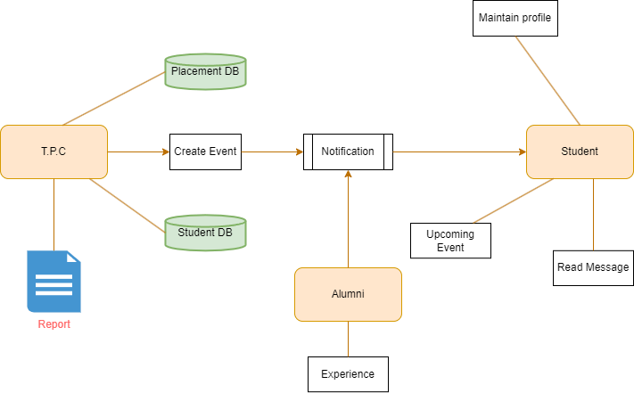

*Fig 4.1.1 Architecture Diagram*

**TPC Module**: TPCs register on the system using their designated email addresses and passwords, with administrators authorizing their accounts based on roles and responsibilities. Authorized TPCs can then log in using their credentials, which are verified against stored data in the MySQL database. Once logged in, TPCs have access to detailed student profiles, including academic backgrounds, contact information, and placement preferences, and they can search and filter these profiles based on criteria such as course, semester, or placement preferences.

Additionally, TPCs can create and manage placement events like job fairs and recruitment sessions, scheduling events, sending invitations to students. Furthermore, TPCs can generate reports based on various criteria such as student names, USN (University Serial Number), semester, or year, providing insights into student demographics, placement trends, and performance metrics.

**Alumni Module:** Alumni can log in using their credentials, through which they can post their experiences and share any job openings available in their company.

**Student Module:** Students begin the process by registering on the system, where they provide necessary details such as name, email address, and password; upon successful registration, students gain access to the dashboard. Subsequently, students log in using their credentials, and the system authenticates this information against stored data in the MySQL database.

Once logged in, students can view and manage their profiles, inputting education details such as academic qualifications, courses, and grades, along with providing contact information like email addresses, phone numbers, and addresses. Furthermore, students can add their placement details, interview experience, and offer letter.

#### Class Diagram

A class diagram provides a static view of an application, showing types of objects and their relationships. It visualizes, describes, and documents various aspects of the system, aiding in software development. It includes class names, attributes, functions, and relationships, facilitating the construction of executable software code.

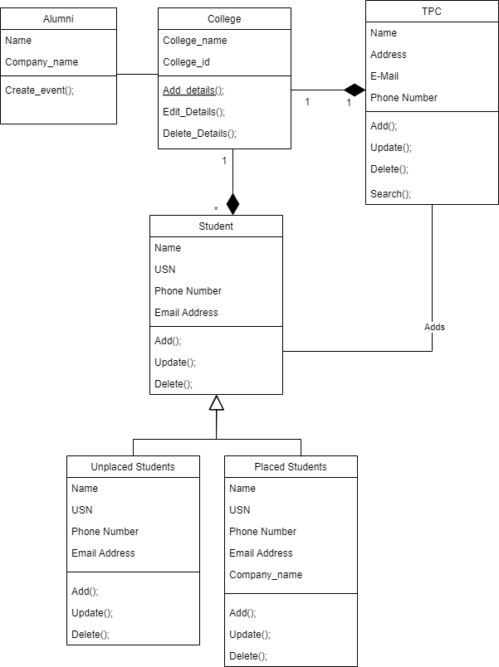

*Fig 4.1.2 Class Diagram*

* College class servers as an abstract class encompassing entities such as students, TPC, and alumni. It features attributes like college name, college ID and location. Additionally, it includes methods such as add details, edit details, delete details.
* Alumni is the class which contains attributes like name, company name and method create event.
* In Students there are two types, placed students and unplaced students. Both placed and unplaced students classes inherits the generalized properties from the student class which is name, USN etc.
* TPC is the class it includes attributes like name, address, e-mail, phone number and methods like add, update, delete, search.

#### Use Case Diagram

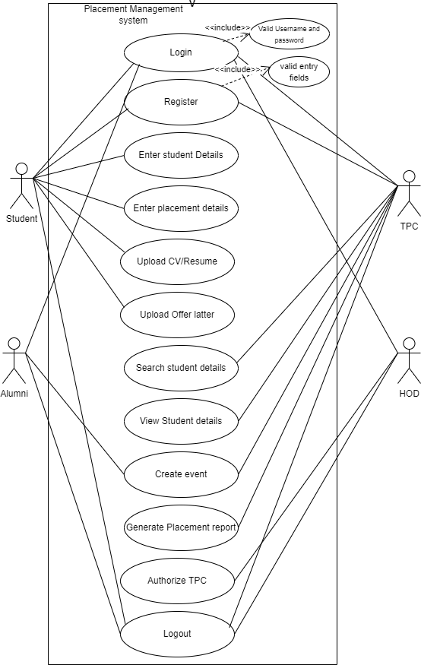A case diagram at its simplest is a simplest of a user’s interaction with the system and depicting the specifications of a user case. A user case diagram can portray the different types of users of a system and various ways that they interact with the system.

*Fig 4.1.3 Use case Diagram*

#### Use Cases:

* + - * **Register:** Users begin by registering on the system, providing necessary details such as name, email address, and password. Upon successful registration, users can login and view the dashboard.
      * **Login:** After successful registration, users log in using their credentials. The system authenticates the login information against the stored data in the MySQL database.
      * **Enter Student Details:** After login of student, he/she can enter their details such as academic details, contact details, educational details, placement details etc.
      * **Upload resume and offer letter:** registered students can uploads their resume and offer letter in their profile.
      * **Search student details:** TPC can search the students based on some criteria such as name, usn, academic year etc.
      * **View student details:** TPCs have access to view detailed student profiles, including academic backgrounds, contact information, and placement preferences.
      * **Create Event:** TPCs can create and manage placement events, including job fairs, campus drives, and recruitment sessions. They schedule events, send invitations to students.
      * **Generate placement report:** TPCs can generate reports based on various criteria, such as student names, USN (University Serial Number), semester, or year. reports provide insights into student demographics, placement trends, and performance metrics.
      * **Authorize TPC:** HoD(admin) has authority to authorize the TPC.
      * **Logout:** Logging out that user access and user credentials are safe after the login session.

#### Actors:

**Student:** students login into the system and they can manage their profiles.

**TPC:** TPC can view the student details, search the students based on search criteria and maintain the reports of placed and unplaced students’ data.

**HoD:** HoD has the authority to authorize TPC.

**Alumni:** Alumni can post their experience and job openings.

#### Sequence Diagram

A Sequence diagram visualizes interactions between objects or components in a system over time, showing message flow and object lifelines. It helps understand the dynamic behavior of a system, facilitating design validation and identifying dependencies.

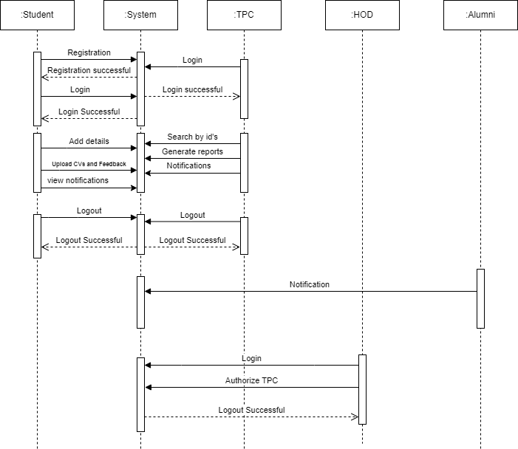

*Fig 4.1.4 Sequence Diagram*

* **Student:** students can login and add details into the system.
* **TPC:** TPC can login and maintains statistics of placement data and give notifications to students about upcoming drives.
* **HoD (Admin):** HoD authorizes TPC. This reduces the unauthorized entry of users as TPC. HoD can also remove such unauthorized users.
* **Alumni:** Alumni can post their experience and job openings. Those entered openings can be seen by Students.

## CHAPTER 5

#### Module Implementation

**IMPLEMENTATION**

The architecture proposed for the Placement Management App capitalizes on the use of Android Studio for frontend development using XML, Java for backend logic, and MySQL for database management. This architecture facilitates a seamless and efficient user experience while significantly reducing reliance on manual systems. Automation plays a pivotal role across all aspects of the applicatio n, enhancing efficiency and accuracy in placement processes.

Through automation, students can effortlessly manage their profiles, academic records, and placement details, reducing the need for manual data entry and paperwork. Administrative tasks, such as user authorization, are streamlined, minimizing manual intervention and potential errors. Training and Placement Coordinators benefit from automated access to student data, event creation, and report generation functionalities, optimizing placement processes. The ability to export placement reports to Excel format further streamlines data analysis and decision-making, reducing the time and effort required for manual reporting. The platform also facilitates automated communication between alumni and current students, enabling seamless sharing of placement opportunities and fostering alumni engagement within the academic community.

The proposed architecture not only modernizes the placement management process but also significantly enhances efficiency, accuracy, and user satisfaction through the strategic implementation of automation.

**User Authentication Module:** This module manages user authentication within the Android Placement Management System, allowing individuals to register and log in securely using credentials stored in a MySQL database managed by XAMPP. Here's how it works:

**User Registration:** Develop a registration process where users can create new accounts by providing necessary information such as email addresses, passwords, and other relevant details. This information is securely stored in the MySQL database.

**User Login:** Implement a login mechanism that authenticates users based on their credentials stored in the MySQL database. Upon successful authentication, users gain access to the application's features and functionalities.

**TPC Module:** The Training and Placement Coordinator (TPC) Module serves as a comprehensive platform for TPCs to manage student placements and events efficiently. Key functionalities include:

**Registration and Login:** Implement registration and login functionalities tailored for TPCs, ensuring secure access to the system using credentials stored in the MySQL database.

**Student and Placement Details:** Develop features that allow TPCs to view detailed information about registered students, including their academic backgrounds, contact details, and placement preferences. Additionally, TPCs should be able to access placement details such as job opportunities and recruitment processes stored in the MySQL database.

**Event Management:** Enable TPCs to create and manage placement events within the application. This includes scheduling events, inviting students, with event details stored in the MySQL database.

**Report Generation:** Implement functionality for TPCs to generate customized reports based on specific categories (e.g., student names, USN, semester, year) using data stored in the MySQL database.

**Admin Module:** The Admin Module is designed for system administrators to manage user accounts and access permissions effectively. Key functionalities include:

**Authorization Management:** Implement functionalities to authorize TPC accounts, granting or revoking access permissions as needed. Admins should have the authority to manage TPC accounts

and ensure compliance with organizational policies, with authorization data stored in the MySQL database.

#### Methodology

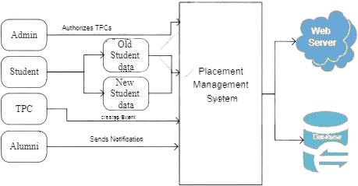

*Fig 5.1 Block Diagram*

#### For Students:

1. **Registration:**

* Students begin by registering on the system, providing necessary details such as name, email address, and password.
* Upon successful registration, students can login and view the dashboard.

#### Login:

* After registration, students log in using their credentials.
* The system authenticates the login information against the stored data in the MySQL database.

#### Profile Management:

* Once logged in, students can view and manage their profiles.
* They input their education details, including academic qualifications, courses, and grades.
* Additionally, students provide contact details such as email address, phone number, and address.

#### Placement Preferences:

* Students input their preferences for placements, including desired industries, job roles, and companies.
* They can update their preferences as needed, ensuring the information is current and relevant.

#### For Placement Coordinators (TPCs):

1. **Registration and Authorization:**

* TPCs register on the system using their designated email addresses and passwords.
* Administrators authorize TPC accounts, granting access to specific functionalities based on their roles and responsibilities.

#### Login:

* Authorized TPCs login using their credentials.
* The system verifies the login information against the stored data in the MySQL database.

#### Student Profile Access:

* TPCs have access to detailed student profiles, including academic backgrounds, contact information, and placement preferences.
* They can search and filter student profiles based on criteria such as course, semester, or placement preferences.

#### Event Management:

* TPCs can create and manage placement events, including job fairs, campus drives, and recruitment sessions.
* They schedule events, send invitations to students, and track RSVPs and attendance.

#### Report Generation:

* TPCs can generate reports based on various criteria, such as student names, USN (University Serial Number), semester, or year.
* Reports provide insights into student demographics, placement trends, and performance metrics.

#### For HOD as admin:

**Registration and Authorization:**

* Administrators register on the system using their designated email addresses and passwords.
* They have the authority to authorize TPC accounts, ensuring compliance with organizational policies.
* They oversee the overall functioning of the system, ensuring it aligns with organizational objectives.
* Following this procedure, users can effectively utilize the system to streamline placement processes.

## CHAPTER 6

### RESULTS

**6.1 Snapshots**

**Splash Page:** also known as a launch screen, A splash screen is mostly the first screen of the app when it is opened. It is a constant screen that appears for a specific amount of time and generally shows for the first time when the app is launched. Splash screen is used to display some basic introductory information such as the company logo, content, etc. just before the app loads completely.

**Home Page:** After splash page it redirects to home page of app. It mainly contains 4 buttons. After clicking particular button it redirects to respective page.

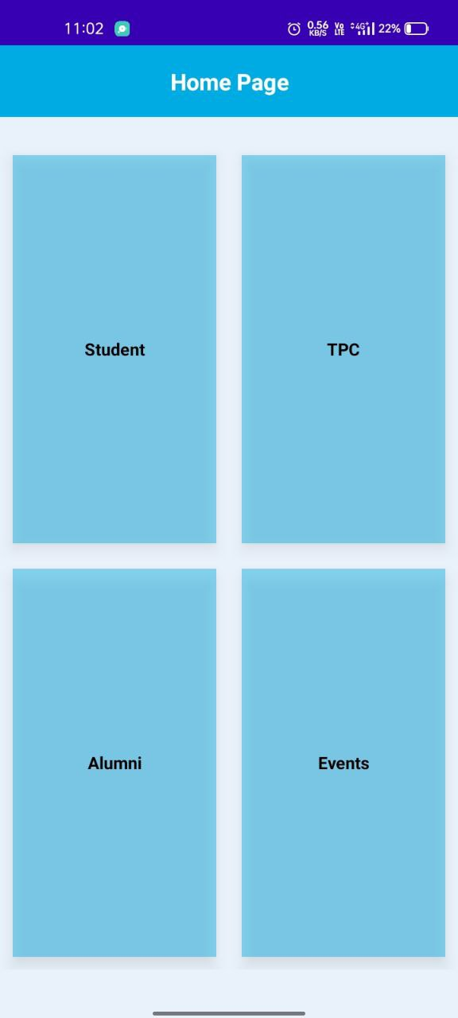

Splash Page Home Page

**Student Login Page:** Students begin by registering on the system, providing necessary details such as name, email address, and password. Upon successful registration, students can login and view the dashboard.

**Student Registration Page:** Students can register themselves by providing necessary information.

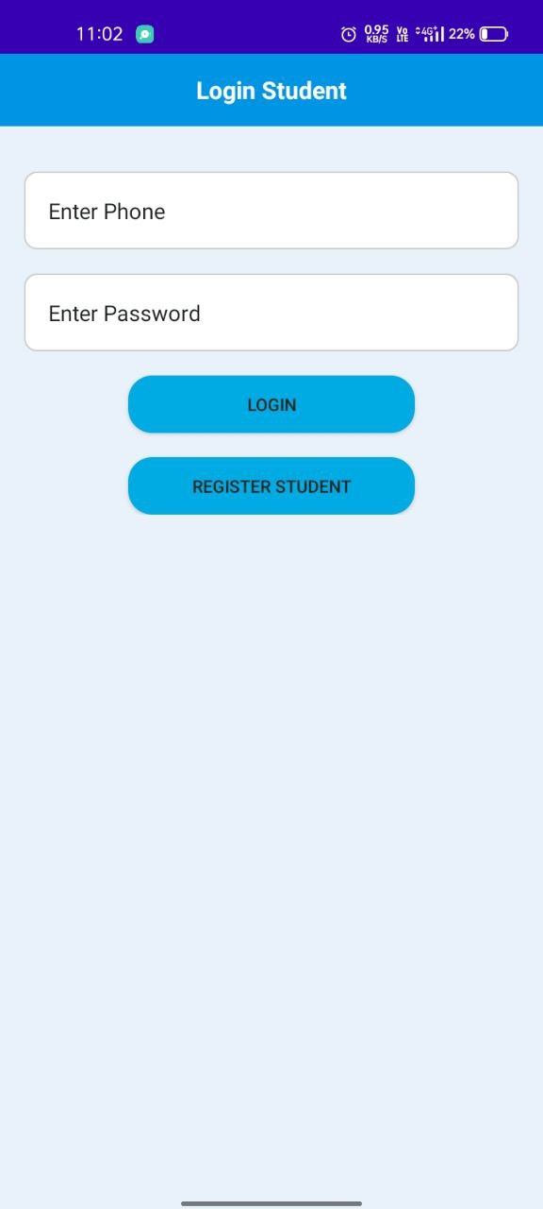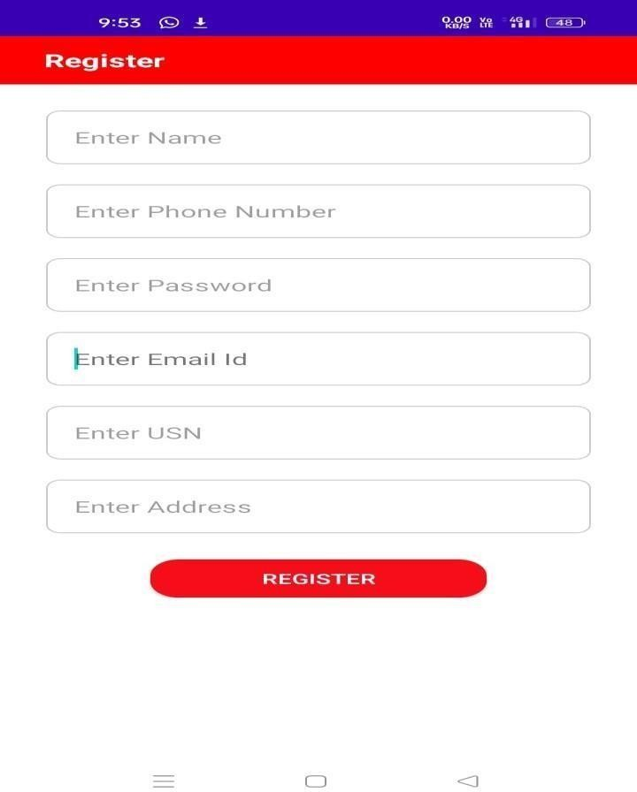

Student Login Page Student Registration Page

**Student Dashboard:** Upon successful login, the student is redirected to the student dashboard page. **Academic Details Page:** After clicking academic details button in student dashboard it directs to the academic details page where students can enter their academic details.

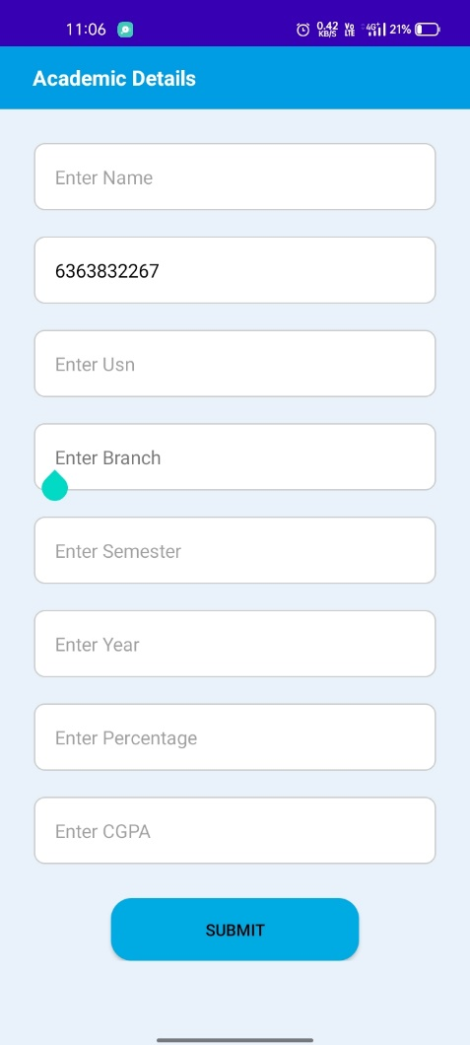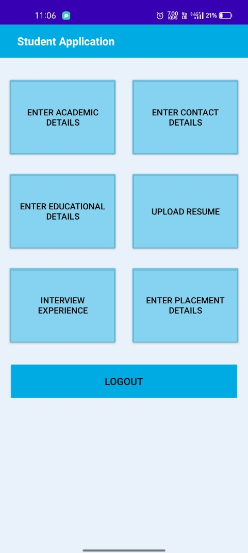

Student Dashboard Academic Details Page

**Contact Details Page:** After clicking contact details button in student dashboard it directs to the contact details page where students can enter their contact details.

**Educational Details Page:** After clicking educational details button in student dashboard it directs to the educational details page where students can enter their educational details.

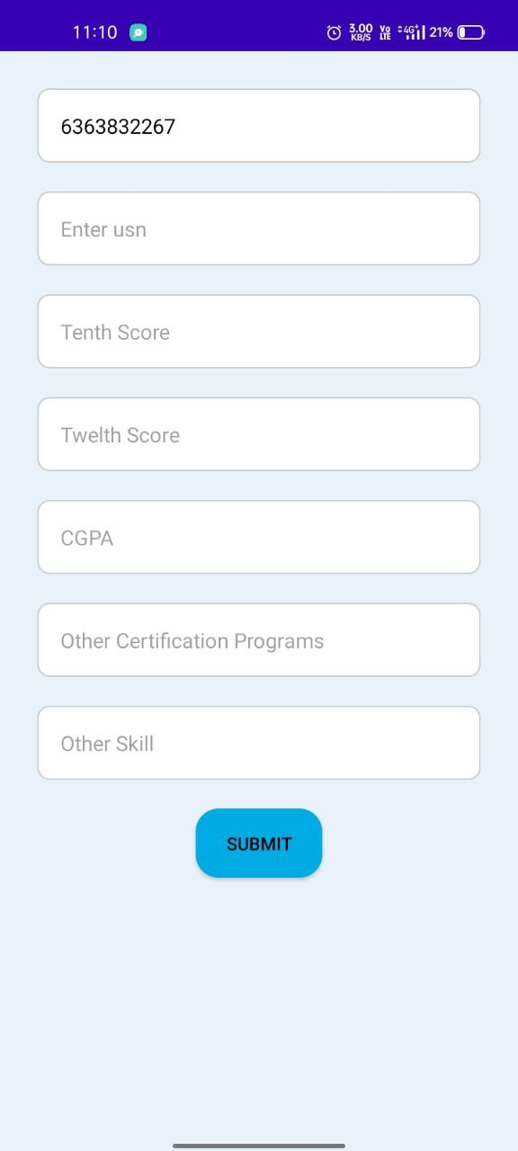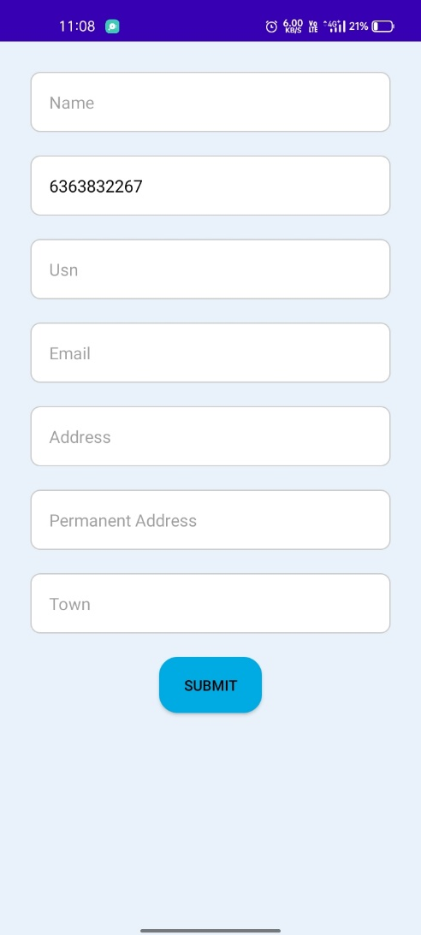

Contact Details Page Educational Details Page

**Upload Resume Page:** After clicking upload resume button in student dashboard it directs to the upload resume page where students can upload their resume.

**Interview Experience Page:** After clicking the "Interview Experience" button on the student dashboard, Users are directed to the interview experience page, where they can post their interview experiences.

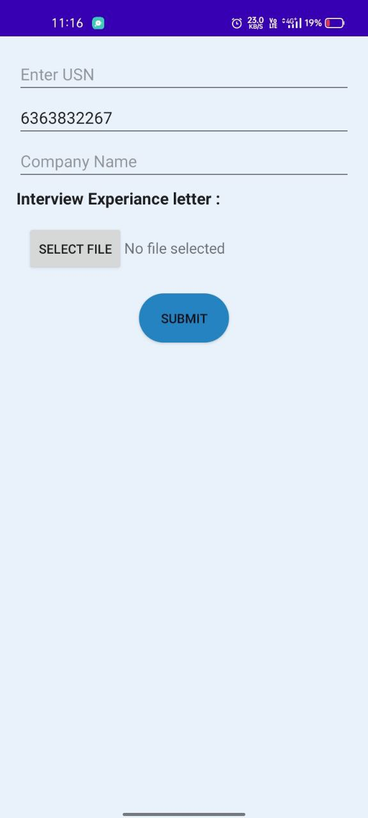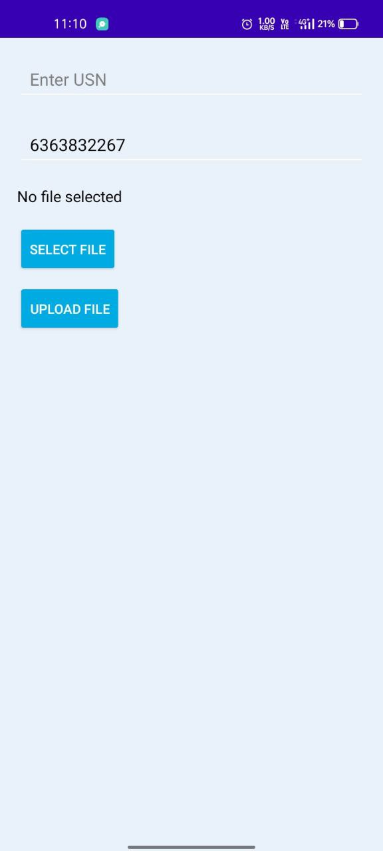

Upload Resume Page Interview Experience Page

**Placement Details Page:** After clicking the "Placement Details" button on the student dashboard, users are directed to the placement details page, where they can enter their placement details.

**TPC Login Page:** TPCs begin by registering on the system, providing necessary details such as phone number and password. Upon successful registration, TPCs can login and view the dashboard.

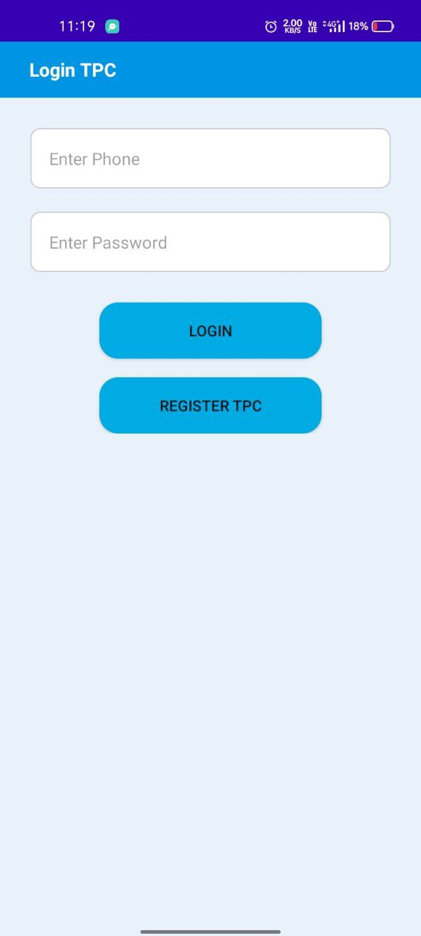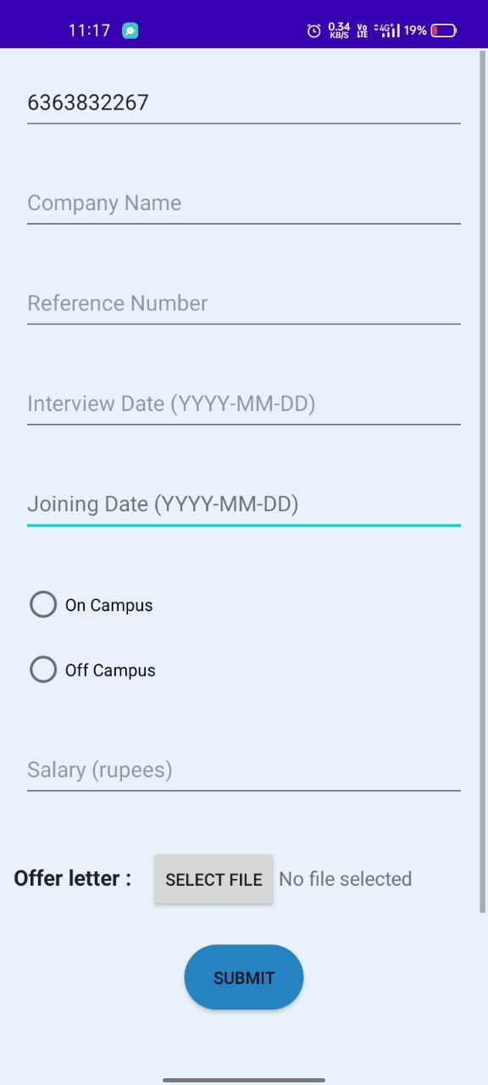

Placement Details Page TPC Login Page

**TPC Registration Page:** TPCs can register themselves by providing necessary information.

**TPC Dashboard:** Upon successful login of TPC, it is redirected to the TPC dashboard page.

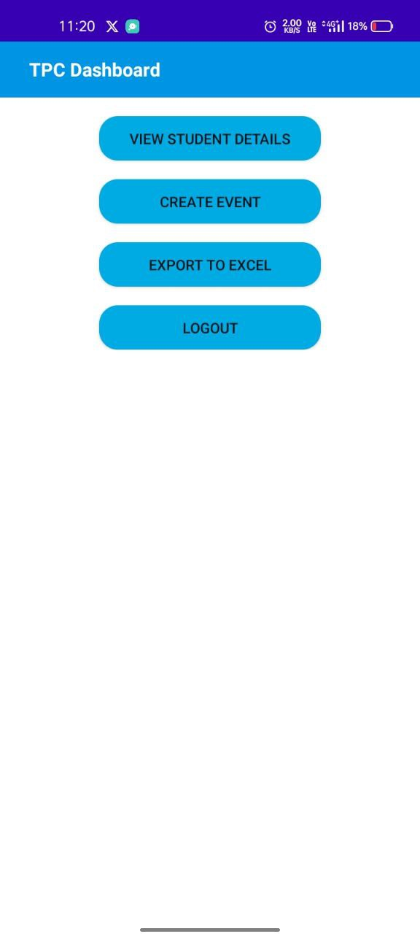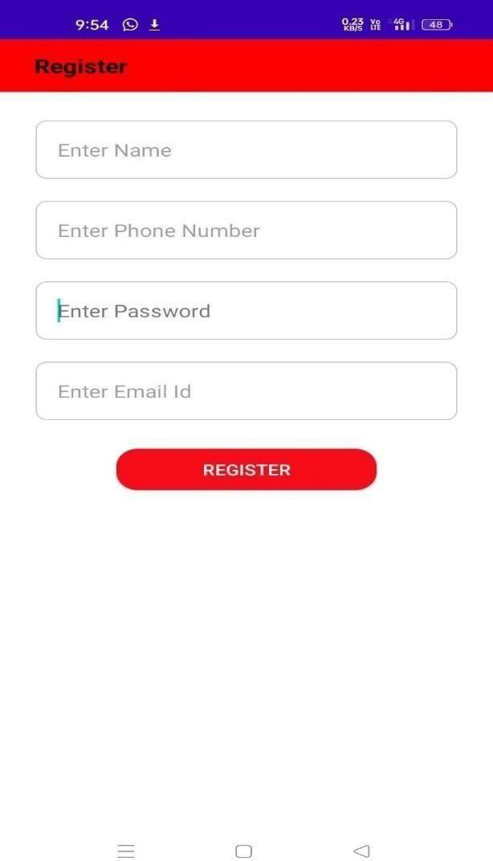

TPC Registration Page TPC Dashboard

**Student Details Page:** After clicking particular student usn from view student detailspage it redirects to thestudent details page where TPC can view the students academic, contact, educational information and resume of student.

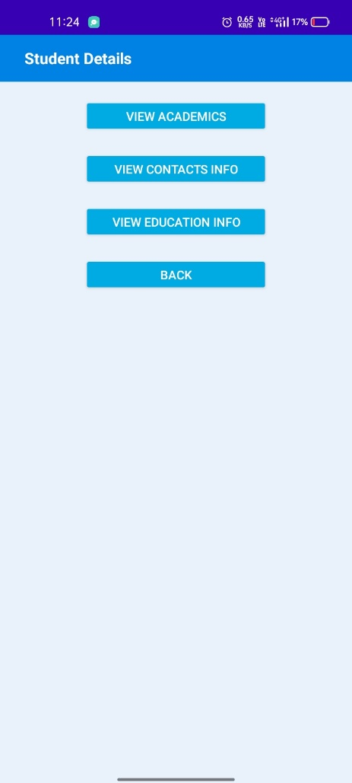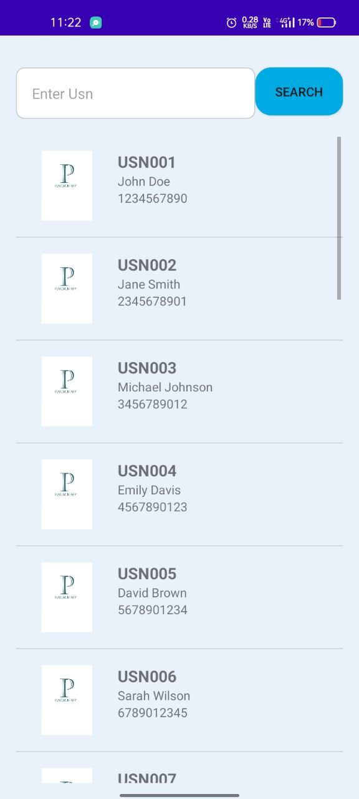

**Create event Page:** After clicking create event button from the TPC dashboard, it redirects to the create event page where TPC can notify to students for upcoming placement drives.This page shows the notifications about upcoming drives.

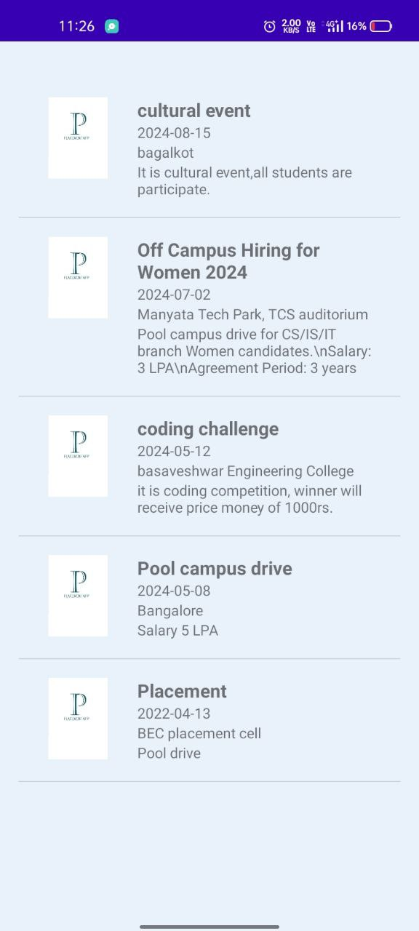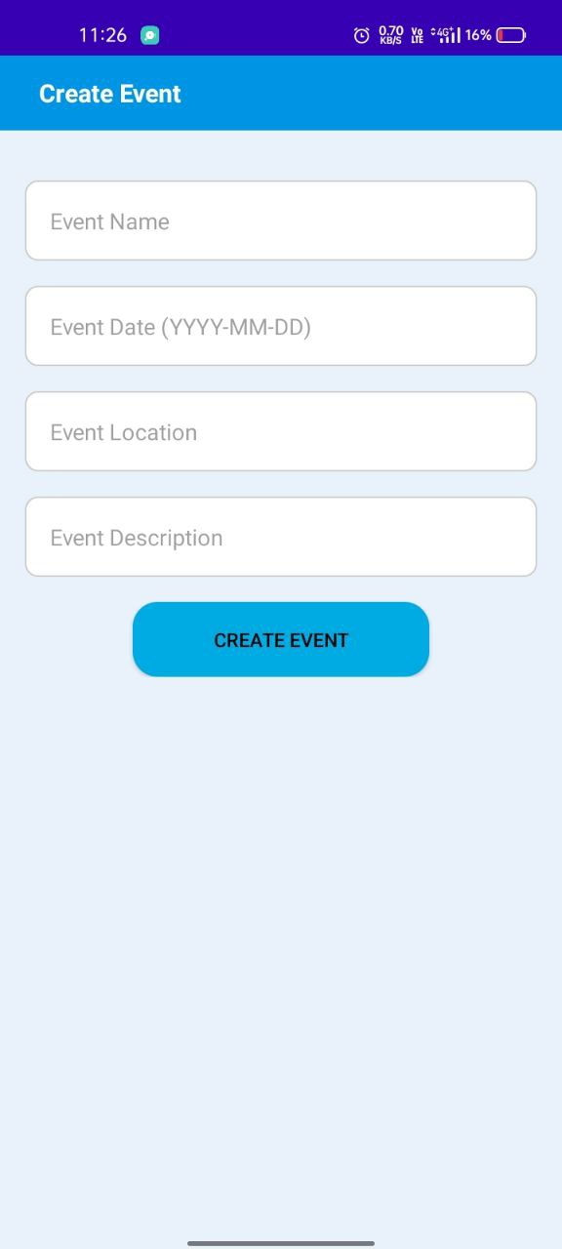

**Report Page:** after clicking “Export to Excel” button from TPC dashboard, it redirects to the report page, it contains two buttons such as old student’s data and new students data, after clicking those buttons it enters into the respective page where TPC can view the report of students.

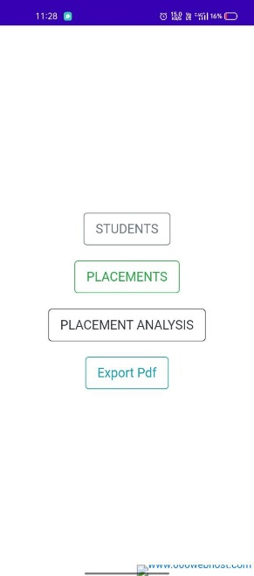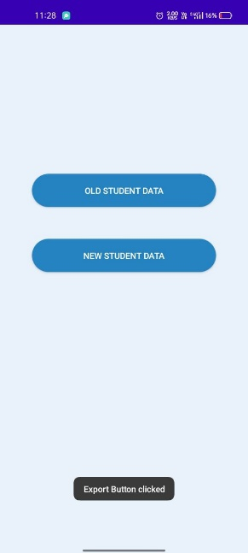

_________________

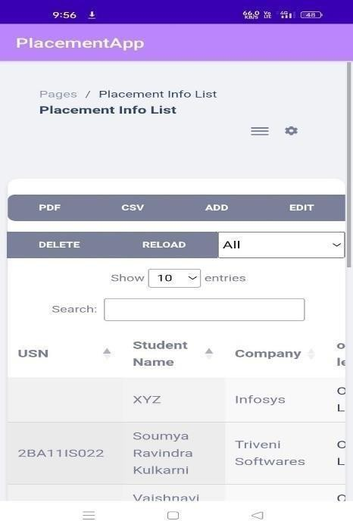

**View Student Record Page:** TPC can view any of the registered student based on some search criteria such as search by name, usn, academic year, company wise etc.

**View Placement Records Page:** TPC can view the placement records of students based on some search criteria.

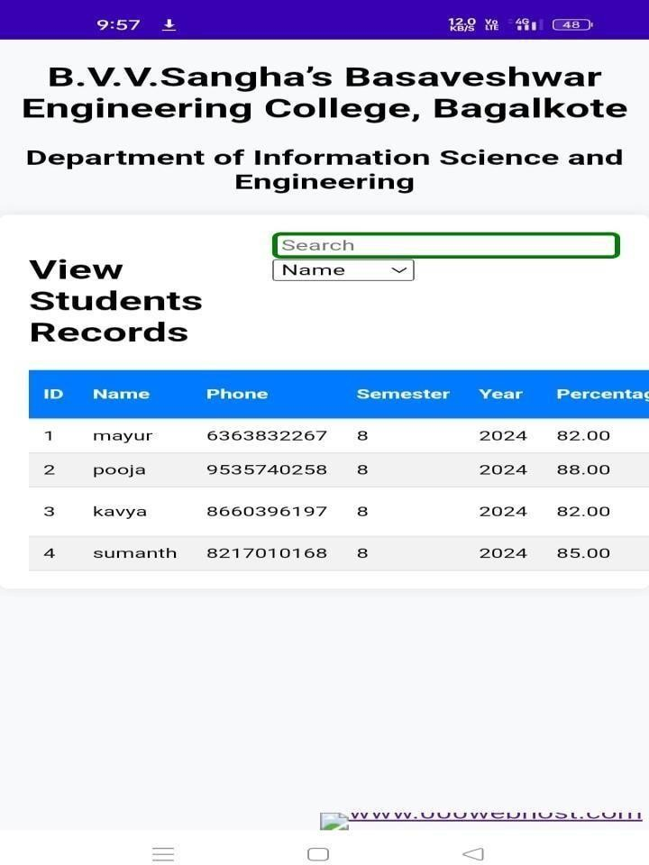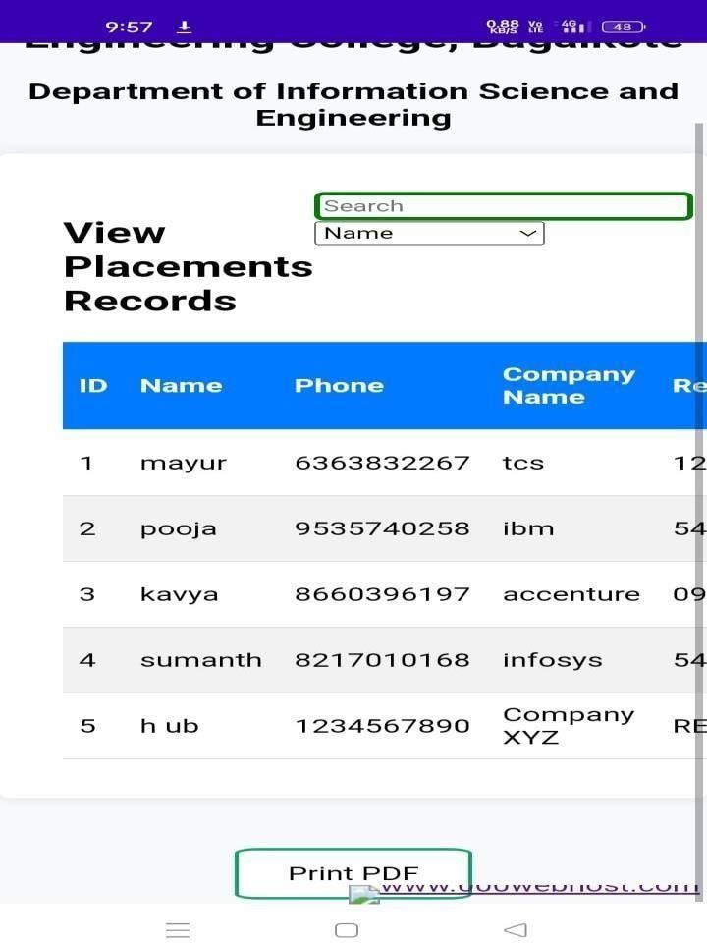

_________________

_________________

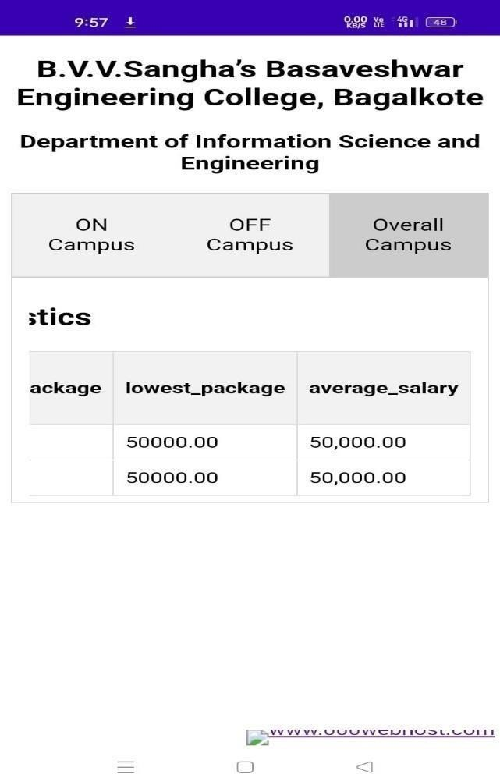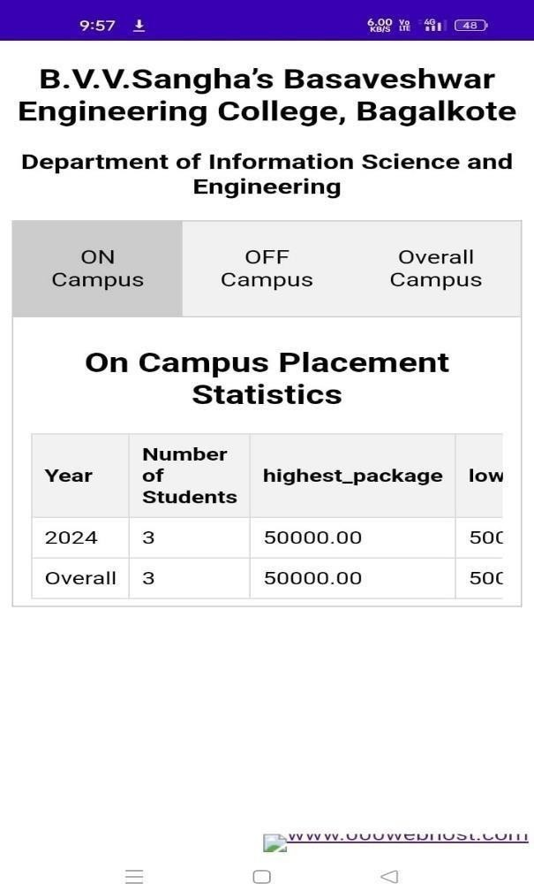

_________________

_________________

_________________

_________________

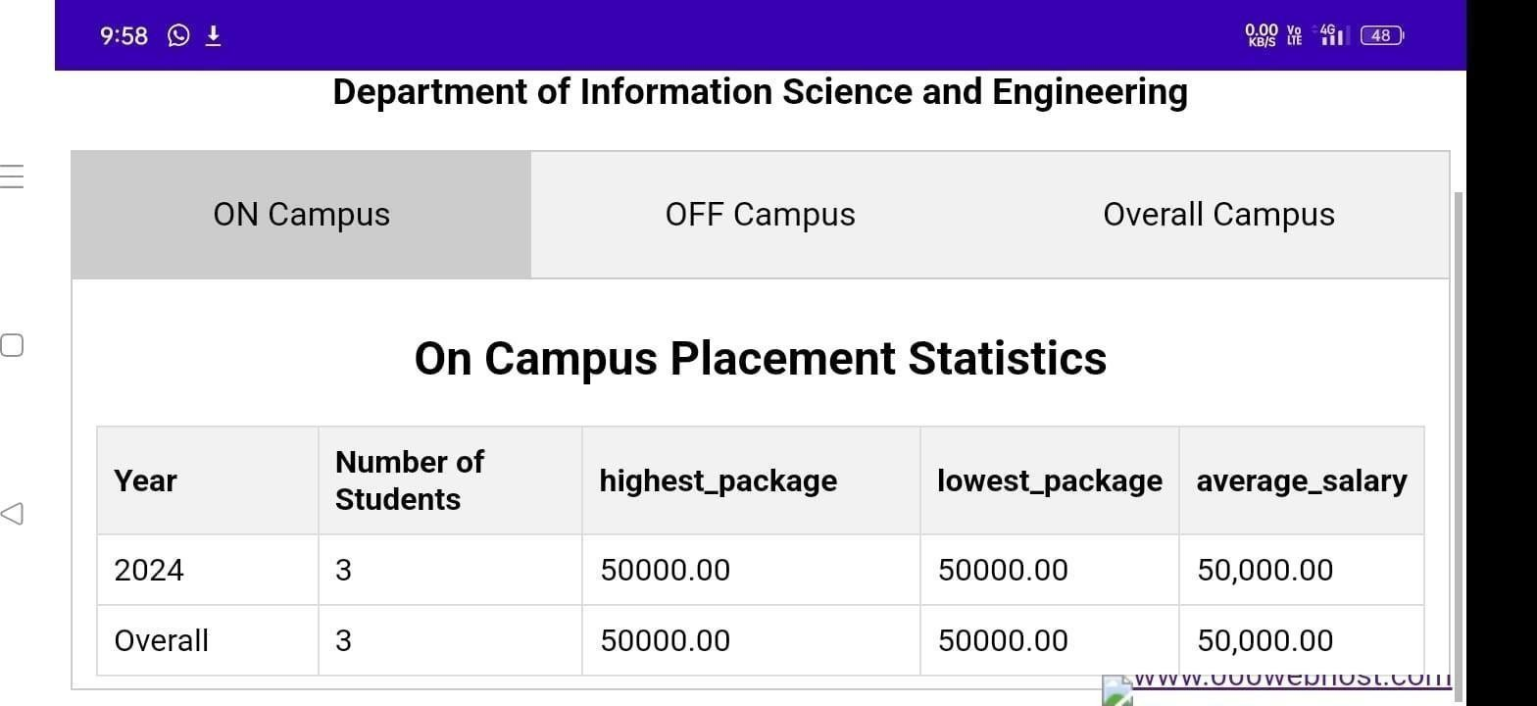

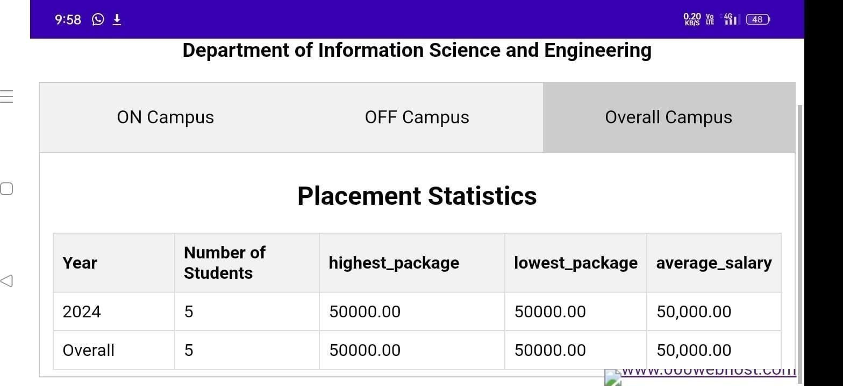

_________________

_________________

**Report generation Page:** TPC can view all the placed students’ information by based on the desired categories like USN, Company Name, Off/On Campus, Reference no., etc.

**Preview Page:** After selecting desired categories, he can generate the report of the selected data. He can get the print of the same.

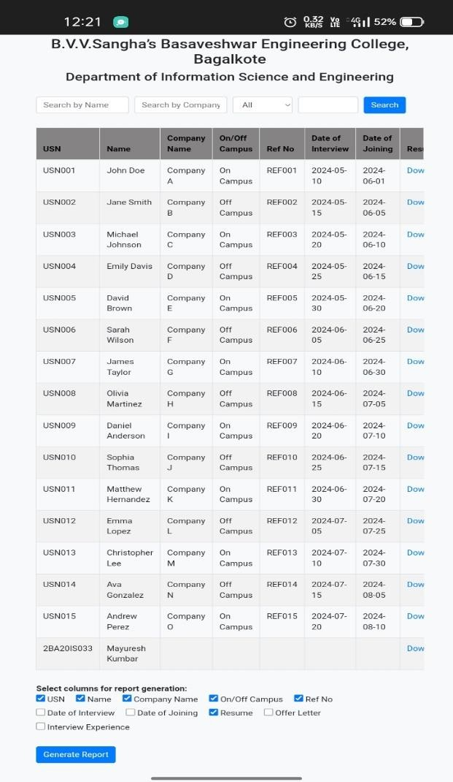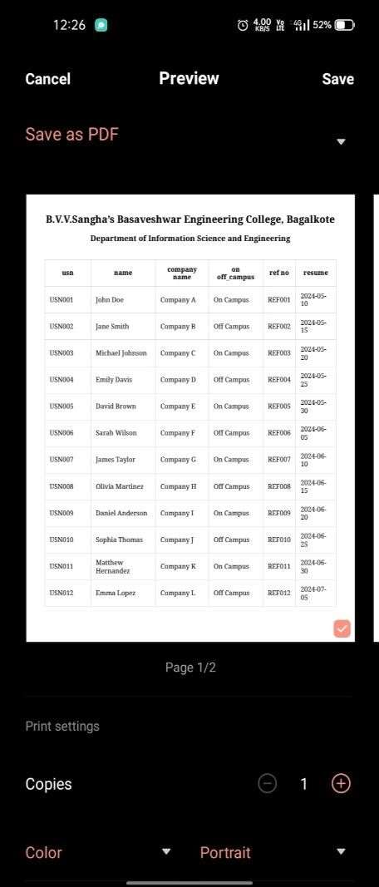

**Alumni Login Page:** Alumni begin by registering on the system, providing necessary details such as phone number and password. Upon successful registration, Alumni can login, post job openings in their company and their experience.

**Alumni Registration Page:** Alumni can register themselves by providing necessary information.

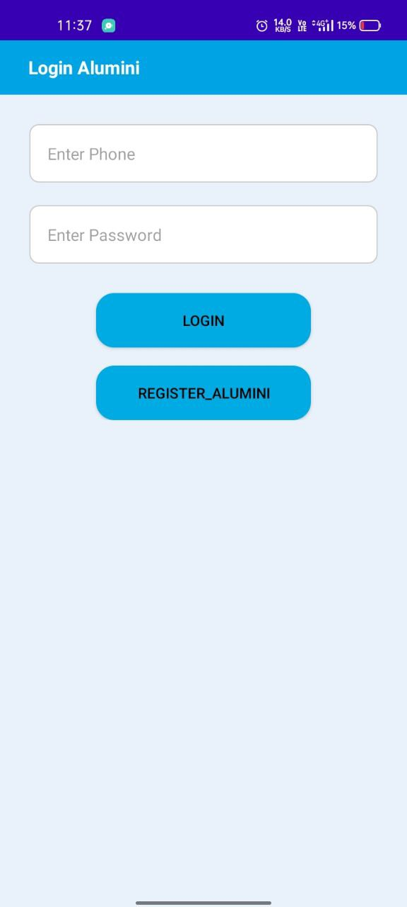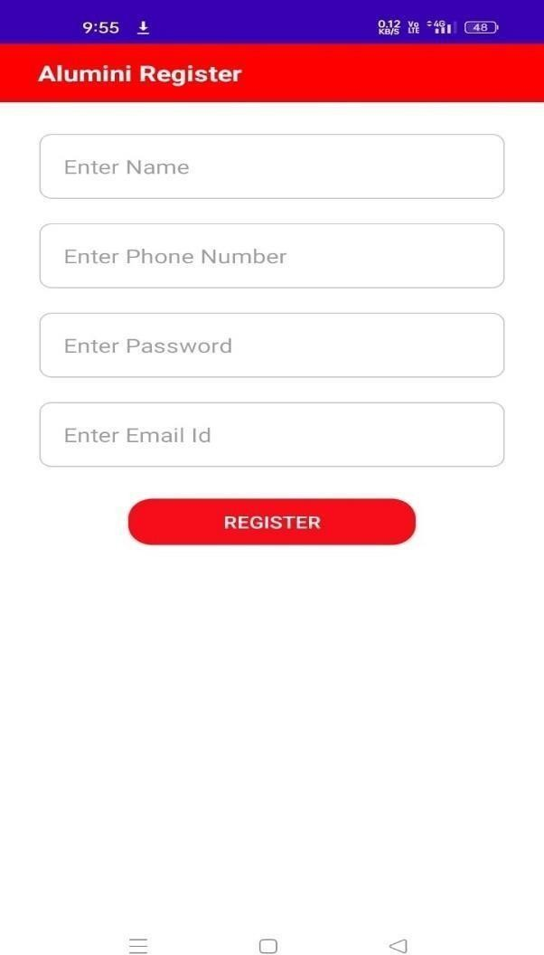

Alumni Login Page Alumni Registration Page

### CONCLUSION

The Placement Management App serves as a crucial and efficient tool for addressing the challenges associated with managing student records within educational institutions. The existing manual systems often struggle to handle the vast amount of data related to placement activities, leading to issues such as miscommunication, data loss, and underutilization of resources. Our literature survey revealed that many institutes face limitations in functionality and lack automation and report generation capabilities in their current systems.

However, the Placement Management App offers a transformative solution by leveraging modern technology, specifically through the use of Smartphones and the Android Studio for developing a user- friendly application. The app streamlines communication and interaction between placement coordinators and students, providing a centralized platform for updating and approving student details. The key advantage lies in automating the manual system, thereby mitigating the risks of data-related problems and fostering effective placement processes.

While the drawbacks of the current systems are evident, the Placement Management App presents an opportunity to overcome these challenges. By embracing automation, the app minimizes the risk of miscommunication and data loss. The user-friendly interface and administrator approval process ensure the accuracy and reliability of records. Moreover, the integration of curriculums in the app allows for a more comprehensive overview of students' skills and qualifications. In essence, the Placement Management App stands as a modernized solution to enhance efficiency, reduce manual errors, and improve the overall effectiveness of training and placement activities in educational institutions.

### REFERENCES

1. Nilesh Rathod, Seema Shah, Kavita Shirsat, “An Interactive Online Training and Placement System”, Internatio nal Journal of Advanced Research in Computer Science and Software Engineering, vol. 3, no. 12.
2. Shilpa Hadkar, Snehal Baing, Trupti Harer, K.T.V. Reddy, “College Collaboration Portal with Training and Placement”, IOSR Journal of Computer Engineering, vol. 16, no. 2, pp. 79-81, April 2013.
3. S. Shah, Kavita Shirsat, “An Interactive Online Training and Placement System”, International Journal of Advanced Research in Computer Science and Software Engineering, vol. 3, no. 12.
4. Alfiya Banu, Manju Bargavi S. K, “A Research on Placement Management System”, International Journal of Advanced Research in Applied Science and Engineering Technology, vol. 10, no. 4.
5. Charlotte Katwa, Kashmira Sanjana, Pooja Parmar, “Final Year Placement Management System”, An Internatio nal Journal of Scientific and Technical Advancements, vol. 2, no. 1, pp. 233-234, 2016.
6. K. Anand, Retheesh D, J. Hemalatha “Android application for training and placement cell”, International Journal of Pure and Applied Mathematics, vol. 119, no. 15, 2018.
7. S. R. Bharamagoudar, R. B. Geeta, and S. G. Totad, “Web based student information management system,” International Journal of Advanced Research in Computer and Communication Engineering, vol. 2, no. 6, 2013.
8. Muniraju N, Amutha N, “Placement Cell Management System”, International Journal for progressive research in Science and Research, vol. 3, no. 3, 2022.
9. Spoorthi M S, Kavana V, Koushik S, Veena, “Review on Placement Management System”, An International open access journal, vol. 9, no. 7, July 2021.
10. Ajeena Sunny, Aneena Felix, Angelin Saji, “Placement Management System for Campus Recruitment”, International Journal of Innovative Science and Research Technology, vol. 5, no. 5, pp. 1705-1710, May 2020.
11. Rupali Komatwar, Swapnil Kamble, Mihir Khedekar, Kishor Walzade, “Placement Support System ” International Journal of Advanced Research in Computer and Communication Engineering, Vol. 5, Issue 1, January 2016 Vol. 5, Issue 1, January 2016.
12. Snehal D. Shriramjwar. Chandure “A study paper on college collaboration portal with training and Placement” International Journal of Research In Science & Engineering.
13. Mulla Kajal, Mahadik Awanti, Pandharpatte Bansod Swapnali, “Online Training and Placement System” International Research Journal of Engineering and Technology (IRJET), 2016.
14. Anjali.V, Jeyalakshmi.PR, Anbubala.R “Web Based Placement Management System”, International Journal of Computer Science and Information Technologies, Vol. 7 (2), 760-763, 2016.
15. Sanket R. Rahul S. Ghule, Shubham K. Brahmankar, Chavan, “A Survey 0n Android App for Traning and Placement cell”, IJARIIE-ISSN(O)-2395-4396 , V0l-1 Issue-4 2015.